**Part 1 Symbols   
  
  
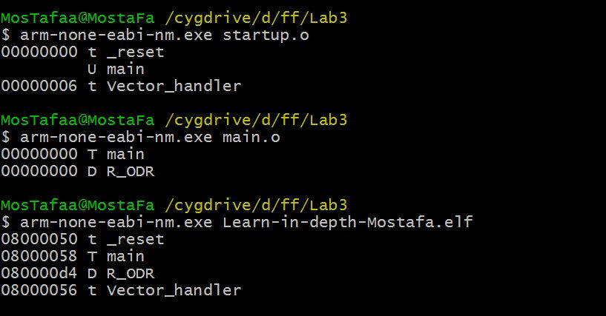   
  
  
Part 2 Symbols  
  
  
